# Broken Links Report

• Broken link on <https://www.utep.edu/cs/advising/old-undergraduate-advising.html> on **Main Content (Top small navigation)** section, the broken link is displayed as: **advising** and the link is pointing to : <https://www.utep.edu/cs/advising/>

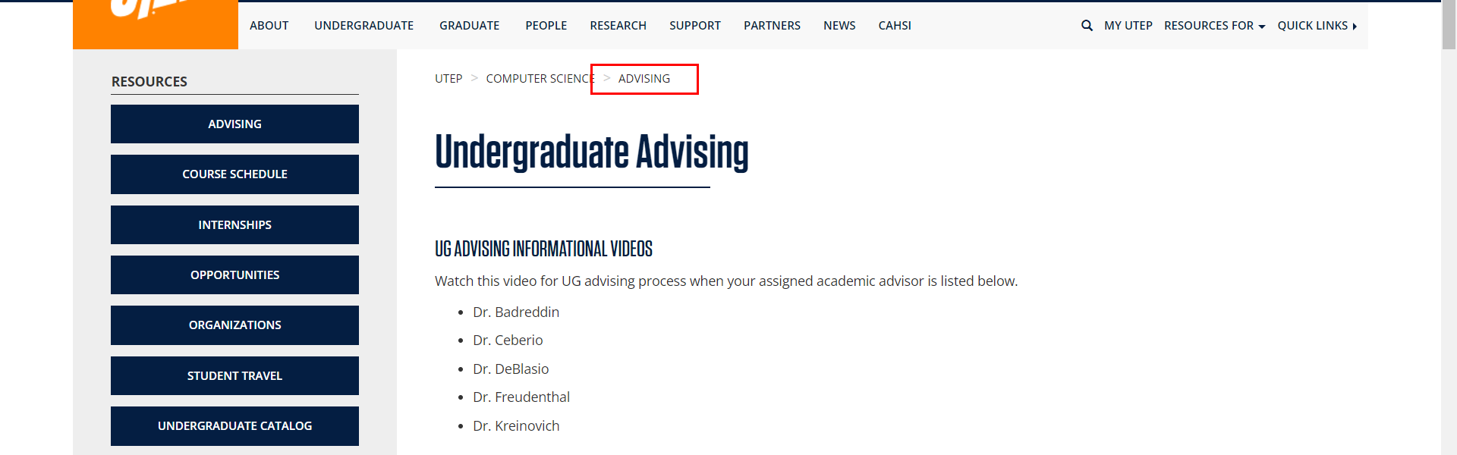

• Broken link on <https://www.utep.edu/cs/advising/old-undergraduate-advising.html> on **Main Content** section, the broken link is displayed as: **Schedule Advising** and the link is pointing to : [https://outlook.office365.com/owa/calendar/ComputerScienceAdvising1@minersutep.onmicrosoft.com/bookings/s/xRUlTyfDmUKdrRH2Gk4xfg2](https://outlook.office365.com/book/ComputerScienceAdvising1@minersutep.onmicrosoft.com/s/xRUlTyfDmUKdrRH2Gk4xfg2?isAnonymous=true)

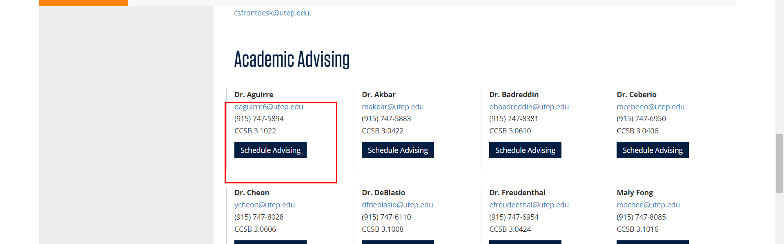

• Broken link on <https://www.utep.edu/cs/advising/old-undergraduate-advising.html> on **Main Content** section, the broken link is displayed as: **Schedule Advising** and the link is pointing to : [https://outlook.office365.com/owa/calendar/ComputerScienceAdvising1@minersutep.onmicrosoft.com/bookings/s/Iq9o6FUtZkyv5lq_n1wHVg2](https://outlook.office365.com/book/ComputerScienceAdvising1@minersutep.onmicrosoft.com/s/Iq9o6FUtZkyv5lq_n1wHVg2?isAnonymous=true)

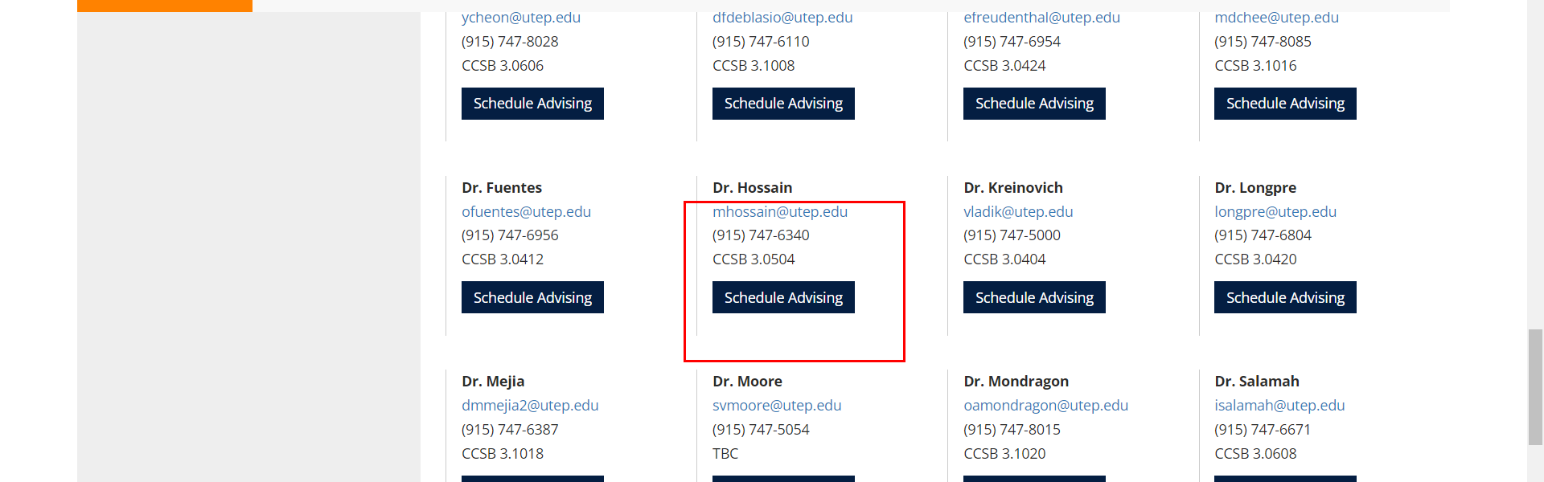

• Broken link on <https://www.utep.edu/cs/advising/old-undergraduate-advising.html> on **Main Content** section, the broken link is displayed as: **Schedule Advising** and the link is pointing to : [https://outlook.office365.com/owa/calendar/ComputerScienceAdvising1@minersutep.onmicrosoft.com/bookings/s/f4wjrjjStEqU4fa6NroUow2](https://outlook.office365.com/book/ComputerScienceAdvising1@minersutep.onmicrosoft.com/s/f4wjrjjStEqU4fa6NroUow2?isAnonymous=true)

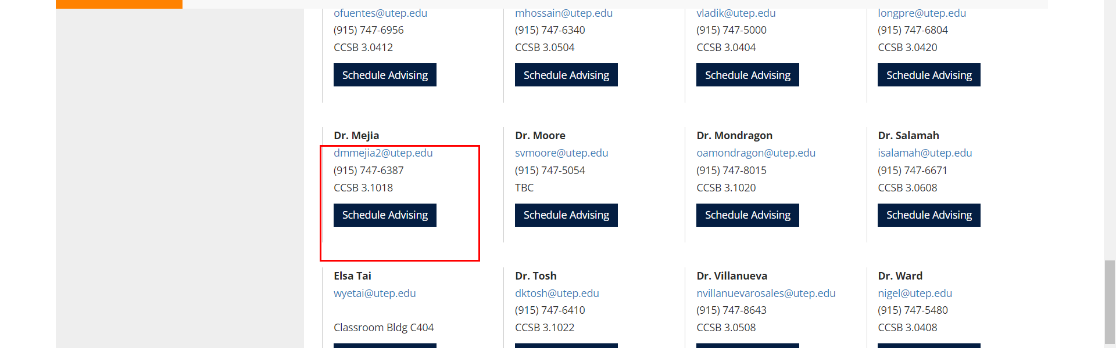

• Broken link on <https://www.utep.edu/cs/advising/old-undergraduate-advising.html> on **Main Content** section, the broken link is displayed as: **Schedule Advising** and the link is pointing to : [https://outlook.office365.com/owa/calendar/ComputerScienceAdvising1@minersutep.onmicrosoft.com/bookings/s/H6GiNlzloEevmntOv0MH2w2](https://outlook.office365.com/book/ComputerScienceAdvising1@minersutep.onmicrosoft.com/s/H6GiNlzloEevmntOv0MH2w2?isAnonymous=true)

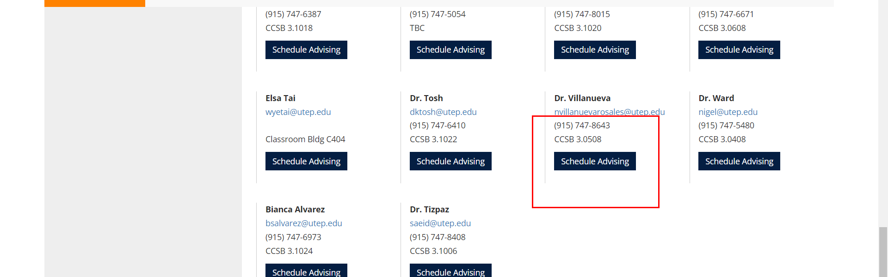

• Broken link on <https://www.utep.edu/cs/advising/old-undergraduate-advising.html> on **Main Content** section, the broken link is displayed as: **Schedule Advising** and the link is pointing to : [https://outlook.office365.com/owa/calendar/ComputerScienceAdvising1@minersutep.onmicrosoft.com/bookings/s/-4fzuzJp4U2bey3rSFkiPw2](https://outlook.office365.com/book/ComputerScienceAdvising1@minersutep.onmicrosoft.com/s/-4fzuzJp4U2bey3rSFkiPw2?isAnonymous=true)

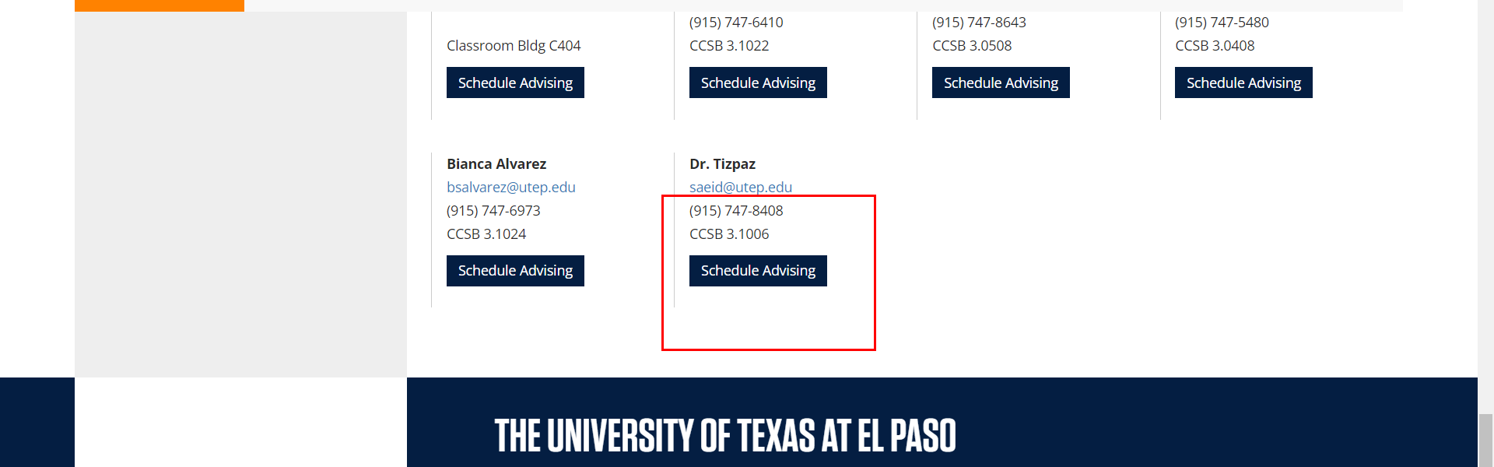

• Broken link on <https://www.utep.edu/cs/advising/old-undergraduate-advising.html> on **Main Content** section, the broken link is displayed as: **Schedule Advising** and the link is pointing to : [https://outlook.office365.com/owa/calendar/ComputerScienceAdvising1@minersutep.onmicrosoft.com/bookings/s/B_779bRXdE2aYLPE0onBgA2](https://outlook.office365.com/book/ComputerScienceAdvising1@minersutep.onmicrosoft.com/s/B_779bRXdE2aYLPE0onBgA2?isAnonymous=true)

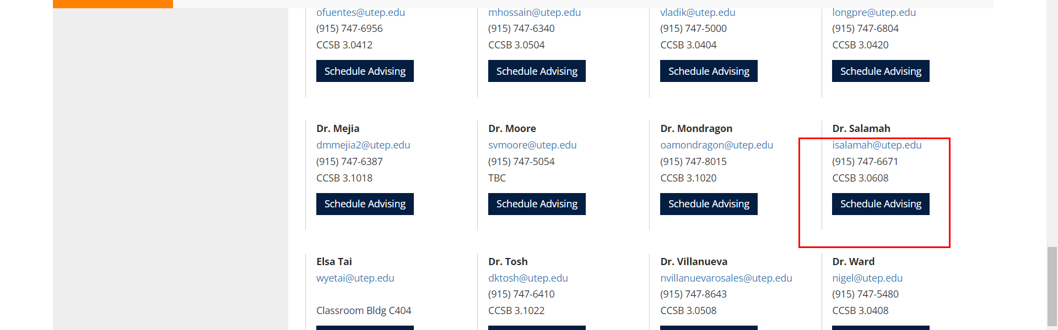

• Broken link on <https://www.utep.edu/cs/advising/old-undergraduate-advising.html> on **Main Content** section, the broken link is displayed as: **Schedule Advising** and the link is pointing to : [https://outlook.office365.com/owa/calendar/ComputerScienceAdvising1@minersutep.onmicrosoft.com/bookings/s/CvJHDJaUT0Cu6LK9YgSldg2](https://outlook.office365.com/book/ComputerScienceAdvising1@minersutep.onmicrosoft.com/s/CvJHDJaUT0Cu6LK9YgSldg2?isAnonymous=true)

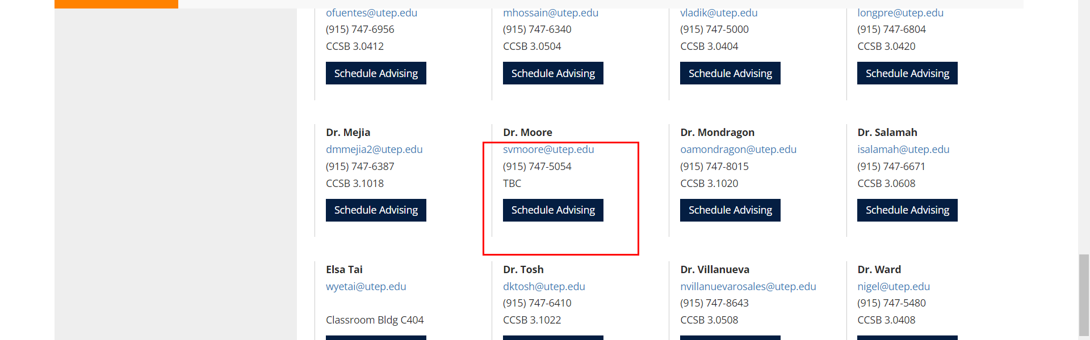

• Broken link on <https://www.utep.edu/cs/advising/old-undergraduate-advising.html> on **Main Content** section, the broken link is displayed as: **Schedule Advising** and the link is pointing to : [https://outlook.office365.com/owa/calendar/ComputerScienceAdvising1@minersutep.onmicrosoft.com/bookings/s/nsbYpiHWjkC1Spyui3o4rA2](https://outlook.office365.com/book/ComputerScienceAdvising1@minersutep.onmicrosoft.com/s/nsbYpiHWjkC1Spyui3o4rA2?isAnonymous=true)

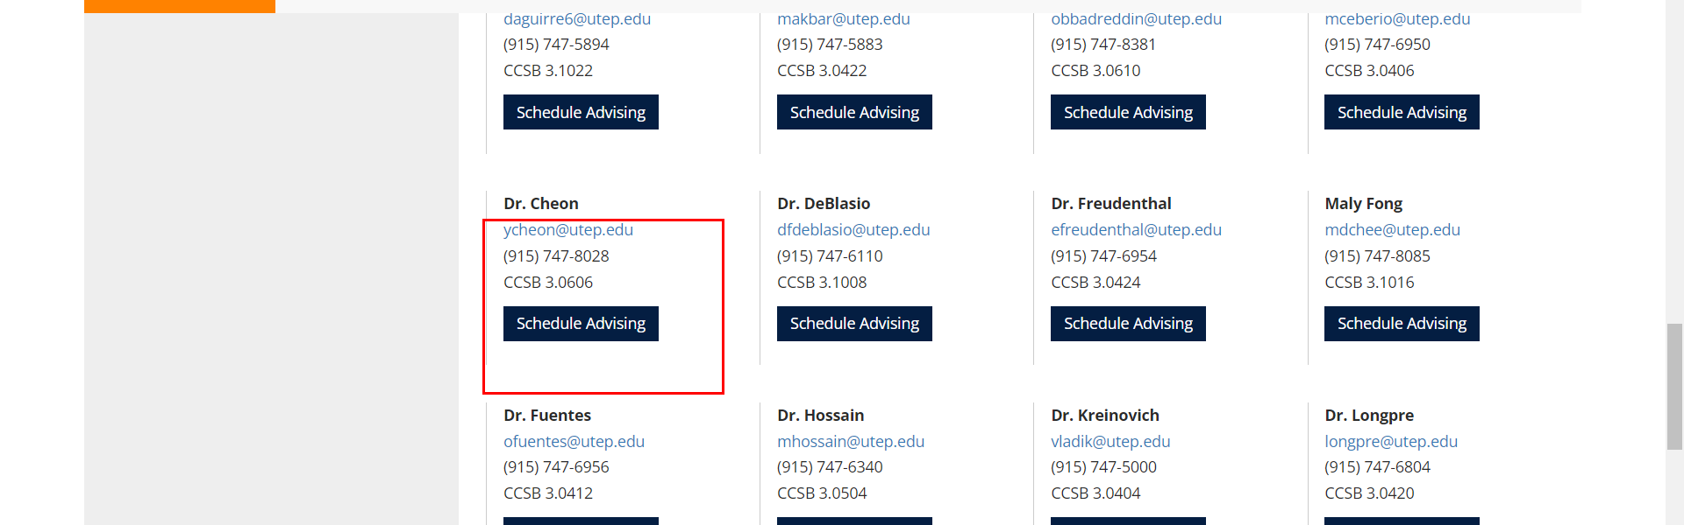

• Broken link on <https://www.utep.edu/cs/advising/old-undergraduate-advising.html> on **Main Content** section, the broken link is displayed as: **Schedule Advising** and the link is pointing to : [https://outlook.office365.com/owa/calendar/ComputerScienceAdvising1@minersutep.onmicrosoft.com/bookings/s/SqQegaoHCEu2q6VG8MHN0A2](https://outlook.office365.com/book/ComputerScienceAdvising1@minersutep.onmicrosoft.com/s/SqQegaoHCEu2q6VG8MHN0A2?isAnonymous=true)

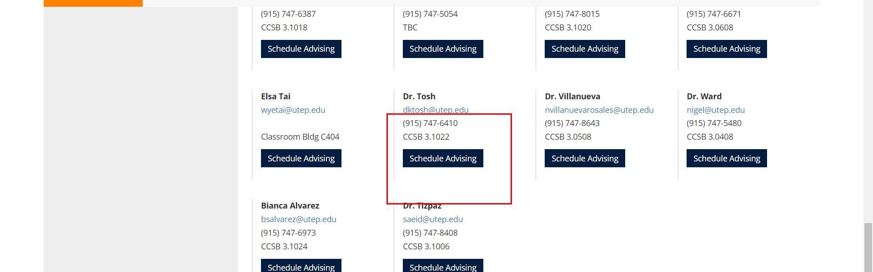

• Broken link on <https://www.utep.edu/cs/advising/old-undergraduate-advising.html> on **Main Content** section, the broken link is displayed as: **Schedule Advising** and the link is pointing to : [https://outlook.office365.com/owa/calendar/ComputerScienceAdvising1@minersutep.onmicrosoft.com/bookings/s/8pmUgMQ89U6NQtxOdnULRg2](https://outlook.office365.com/book/ComputerScienceAdvising1@minersutep.onmicrosoft.com/s/8pmUgMQ89U6NQtxOdnULRg2?isAnonymous=true)

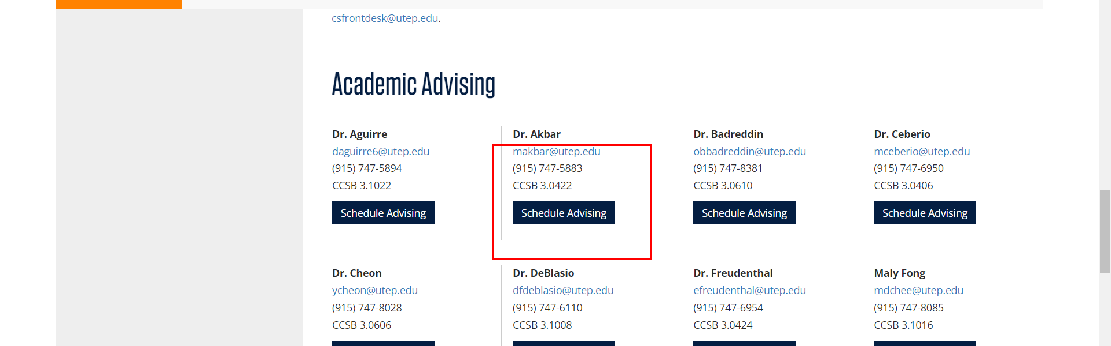

• Broken link on <https://www.utep.edu/cs/advising/old-undergraduate-advising.html> on **Main Content** section, the broken link is displayed as: **Schedule Advising** and the link is pointing to : [https://outlook.office365.com/owa/calendar/ComputerScienceAdvising1@minersutep.onmicrosoft.com/bookings/s/R171XriyvkSfOYZt7opfCw2](https://outlook.office365.com/book/ComputerScienceAdvising1@minersutep.onmicrosoft.com/s/R171XriyvkSfOYZt7opfCw2?isAnonymous=true)

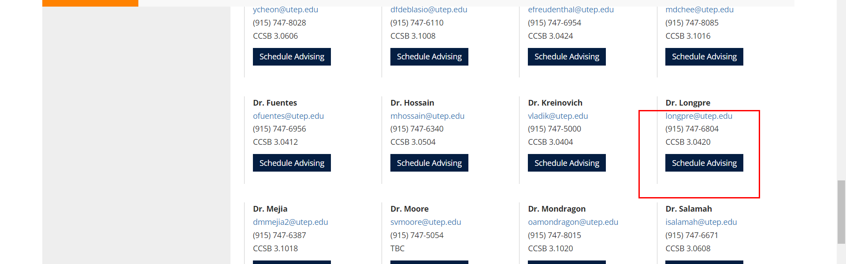

• Broken link on <https://www.utep.edu/cs/advising/old-undergraduate-advising.html> on **Main Content** section, the broken link is displayed as: **Schedule Advising** and the link is pointing to : [https://outlook.office365.com/owa/calendar/ComputerScienceAdvising1@minersutep.onmicrosoft.com/bookings/s/Jtdk3tLIIkuXtUjOYsn3bQ2](https://outlook.office365.com/book/ComputerScienceAdvising1@minersutep.onmicrosoft.com/s/Jtdk3tLIIkuXtUjOYsn3bQ2?isAnonymous=true)

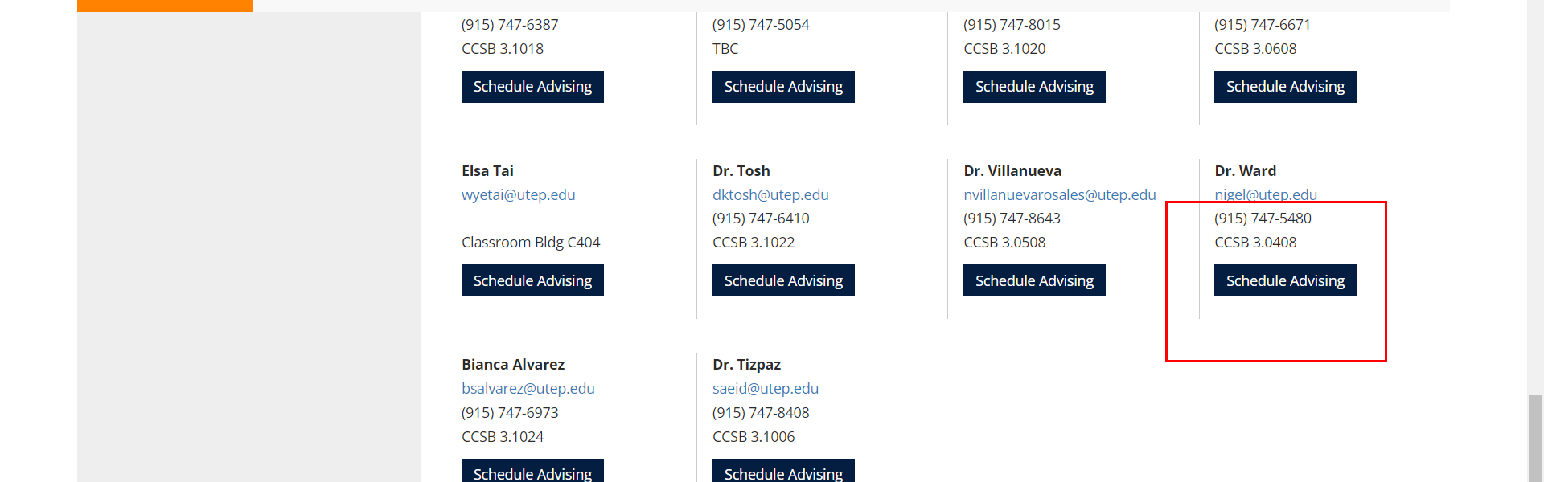

• Broken link on <https://www.utep.edu/cs/advising/old-undergraduate-advising.html> on **Main Content** section, the broken link is displayed as: **Schedule Advising** and the link is pointing to : [https://outlook.office365.com/owa/calendar/ComputerScienceAdvising1@minersutep.onmicrosoft.com/bookings/s/JWiEk-jt7EKSZxrVB5uhUA2](https://outlook.office365.com/book/ComputerScienceAdvising1@minersutep.onmicrosoft.com/s/JWiEk-jt7EKSZxrVB5uhUA2?isAnonymous=true)

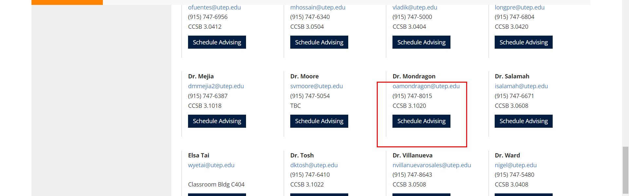

• Broken link on <https://www.utep.edu/cs/advising/old-undergraduate-advising.html> on **Main Content** section, the broken link is displayed as: **Schedule Advising** and the link is pointing to : [https://outlook.office365.com/owa/calendar/ComputerScienceAdvising1@minersutep.onmicrosoft.com/bookings/s/8DPH14vBFUGx4jmopfqBZQ2](https://outlook.office365.com/book/ComputerScienceAdvising1@minersutep.onmicrosoft.com/s/8DPH14vBFUGx4jmopfqBZQ2?isAnonymous=true)

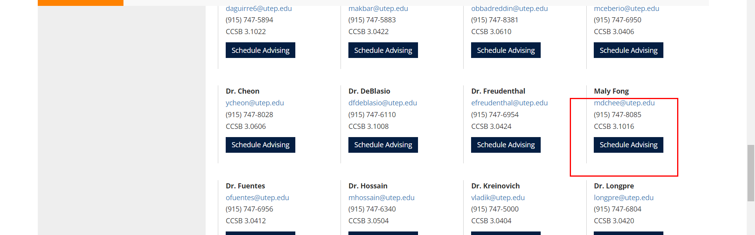

• Broken link on <https://www.utep.edu/cs/advising/old-undergraduate-advising.html> on **Main Content** section, the broken link is displayed as: **Schedule Advising** and the link is pointing to : [https://outlook.office365.com/owa/calendar/ComputerScienceAdvising1@minersutep.onmicrosoft.com/bookings/s/jmmLtDS99kmaygXuqpn-AA2](https://outlook.office365.com/book/ComputerScienceAdvising1@minersutep.onmicrosoft.com/s/jmmLtDS99kmaygXuqpn-AA2?isAnonymous=true)

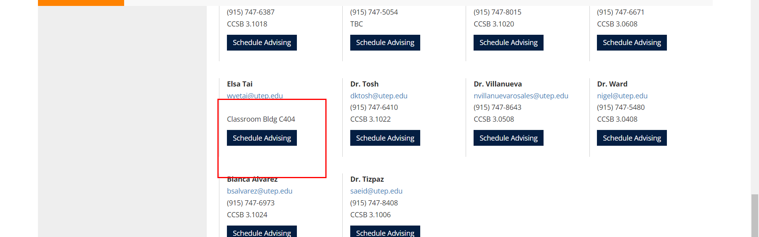

• Broken link on <https://www.utep.edu/cs/advising/old-undergraduate-advising.html> on **Main Content** section, the broken link is displayed as: **Schedule Advising** and the link is pointing to : [https://outlook.office365.com/owa/calendar/ComputerScienceAdvising1@minersutep.onmicrosoft.com/bookings/s/_CV8tYsYfEuhmMitMtOGPw2](https://outlook.office365.com/book/ComputerScienceAdvising1@minersutep.onmicrosoft.com/s/_CV8tYsYfEuhmMitMtOGPw2?isAnonymous=true)

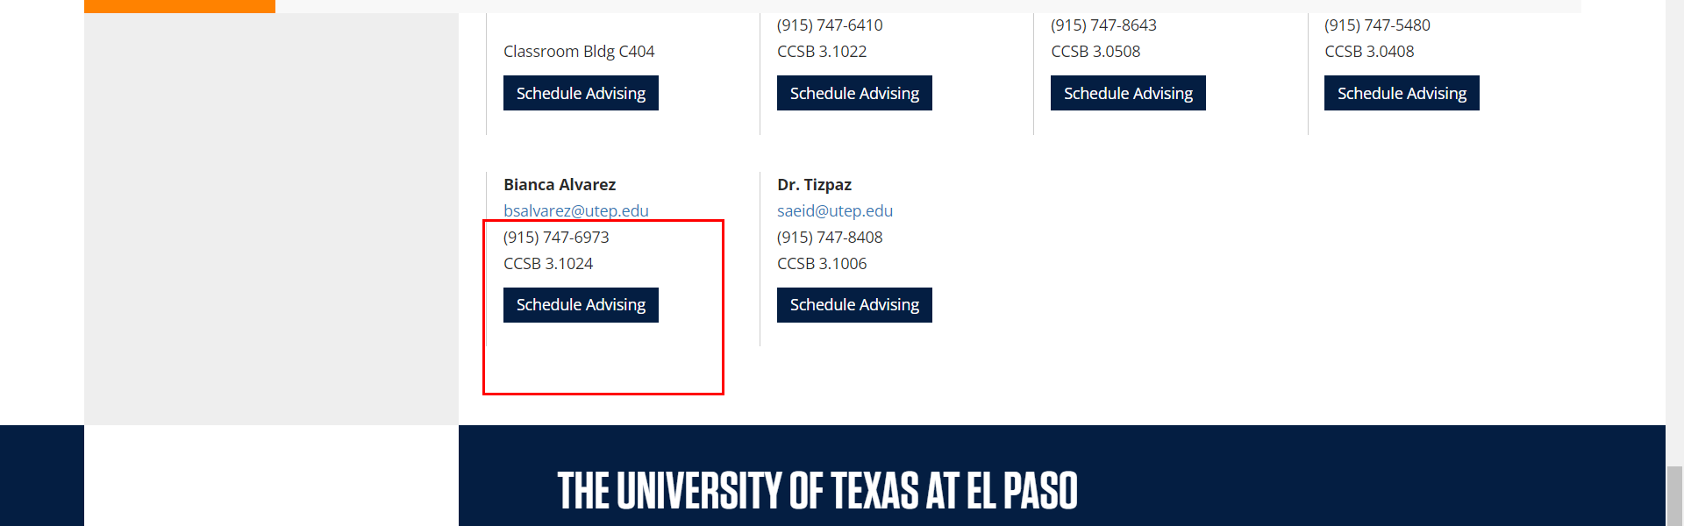

• Broken link on <https://www.utep.edu/cs/advising/old-undergraduate-advising.html> on **Main Content** section, the broken link is displayed as: **Schedule Advising** and the link is pointing to : [https://outlook.office365.com/owa/calendar/ComputerScienceAdvising1@minersutep.onmicrosoft.com/bookings/s/DoiIcGQhQku4Tq2l2ghX2w2](https://outlook.office365.com/book/ComputerScienceAdvising1@minersutep.onmicrosoft.com/s/DoiIcGQhQku4Tq2l2ghX2w2?isAnonymous=true)

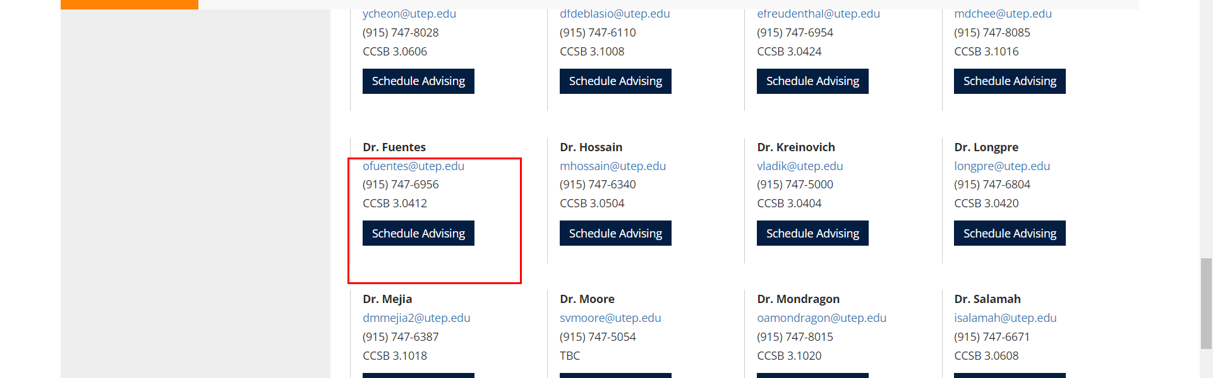

• Broken link on <https://www.utep.edu/cs/advising/old2-undergraduate-advising.html> on **Main Content (Top small navigation)** section, the broken link is displayed as: **advising** and the link is pointing to : <https://www.utep.edu/cs/advising/>

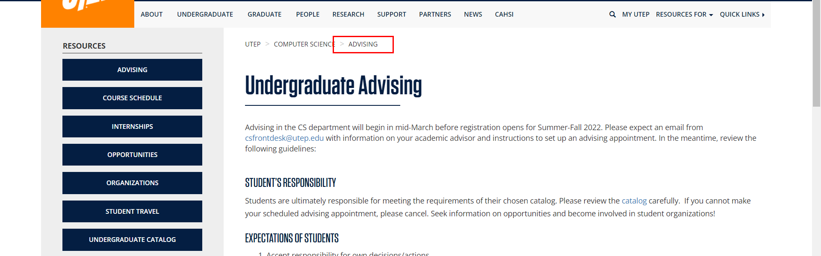

• Broken link on <https://www.utep.edu/cs/advising/Advising_page/graduate-advising-old.html> on **Main Content (Top small navigation)** section, the broken link is displayed as: **advising** and the link is pointing to : <https://www.utep.edu/cs/advising/>

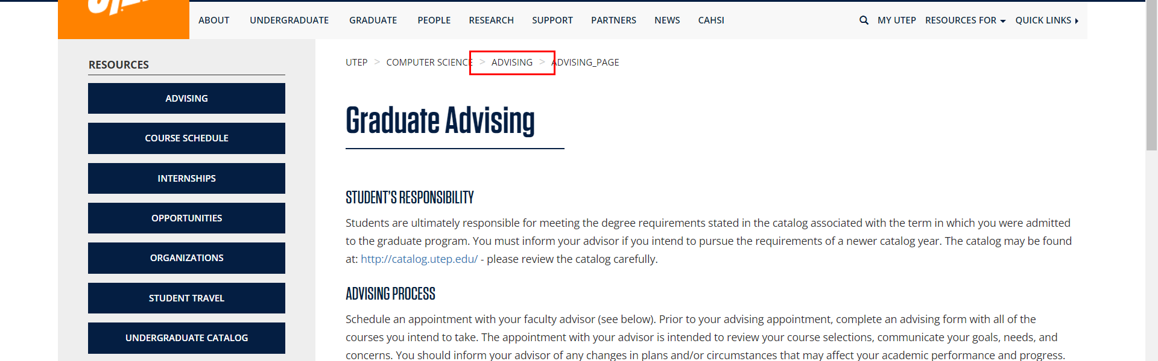

• Broken link on <https://www.utep.edu/cs/advising/Advising_page/graduate-advising-old.html> on **Main Content** section, the broken link is displayed as: **Schedule Advising** and the link is pointing to : [https://outlook.office365.com/owa/calendar/ComputerScienceAdvising1@minersutep.onmicrosoft.com/bookings/s/JWiEk-jt7EKSZxrVB5uhUA2](https://outlook.office365.com/book/ComputerScienceAdvising1@minersutep.onmicrosoft.com/s/JWiEk-jt7EKSZxrVB5uhUA2?isAnonymous=true)

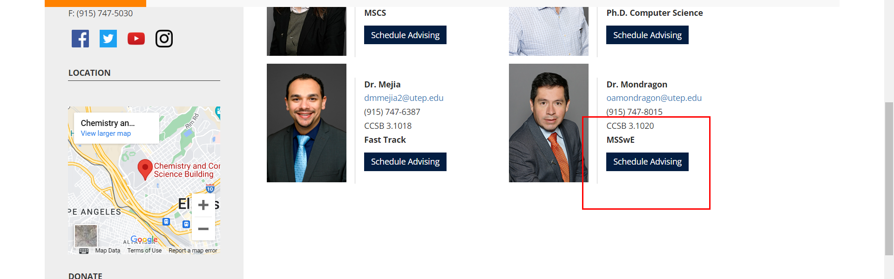

• Broken link on <https://www.utep.edu/cs/advising/Advising_page/graduate-advising-old.html> on **Main Content** section, the broken link is displayed as: **Schedule Advising** and the link is pointing to : [https://outlook.office365.com/owa/calendar/DrMejiaAppointments@minersutep.onmicrosoft.com/bookings/s/6cJsoBv1e0i0z2ESBpIiEQ2](https://outlook.office365.com/book/DrMejiaAppointments@minersutep.onmicrosoft.com/s/6cJsoBv1e0i0z2ESBpIiEQ2?isAnonymous=true)

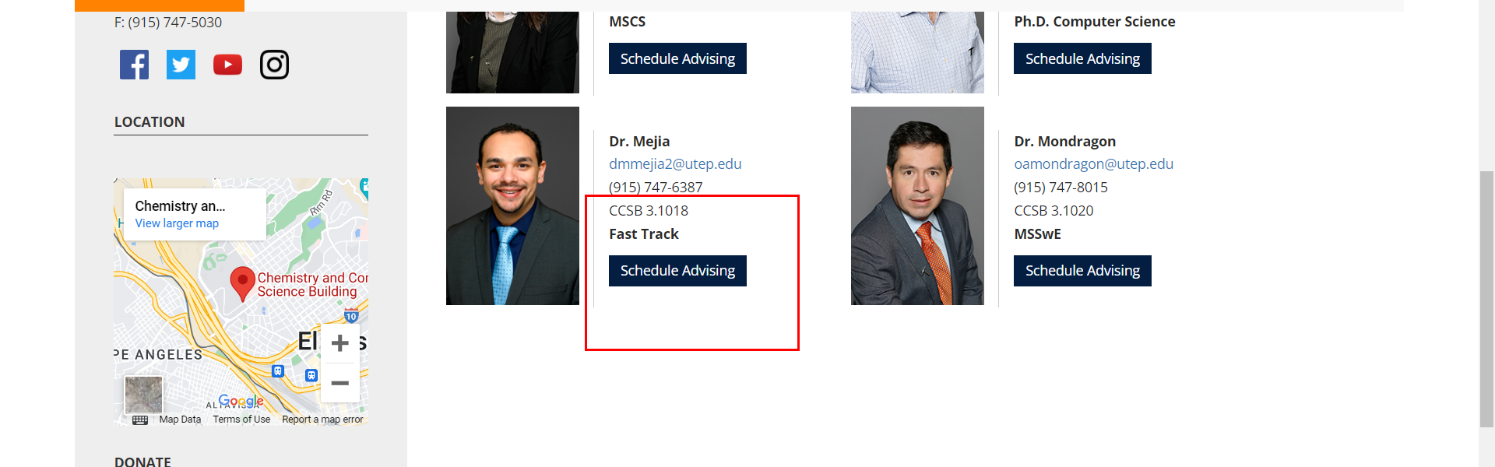

• Broken link on <https://www.utep.edu/cs/advising/Advising_page/graduate-advising-old.html> on **Main Content** section, the broken link is displayed as: **Schedule Advising** and the link is pointing to : [https://outlook.office365.com/owa/calendar/ComputerScienceAdvising1@minersutep.onmicrosoft.com/bookings/s/MMitx8tTB0K7GXt3HyJH5A2](https://outlook.office365.com/book/ComputerScienceAdvising1@minersutep.onmicrosoft.com/s/MMitx8tTB0K7GXt3HyJH5A2?isAnonymous=true)

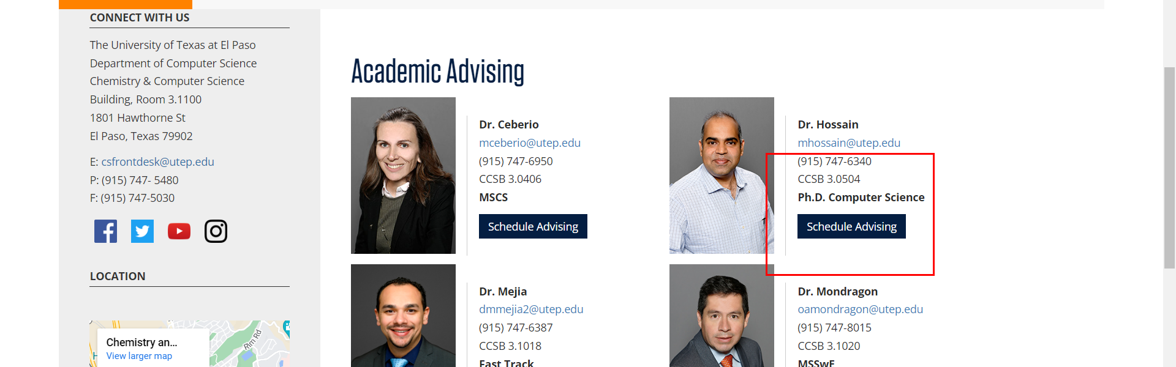

• Broken link on <https://www.utep.edu/cs/advising/Advising_page/graduate-advising.html> on **Main Content (Top small navigation)** section, the broken link is displayed as: **advising** and the link is pointing to : <https://www.utep.edu/cs/advising/>

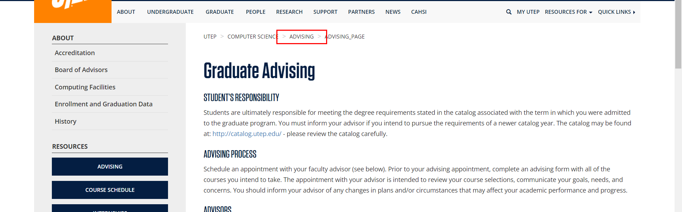

• Broken link on <https://www.utep.edu/cs/advising/Advising_page/graduate-advising.html> on **Main Content** section, the broken link is displayed as: **Schedule Advising** and the link is pointing to : [https://outlook.office365.com/owa/calendar/DrMejiaAppointments@minersutep.onmicrosoft.com/bookings/s/6cJsoBv1e0i0z2ESBpIiEQ2](https://outlook.office365.com/book/DrMejiaAppointments@minersutep.onmicrosoft.com/s/6cJsoBv1e0i0z2ESBpIiEQ2?isAnonymous=true)

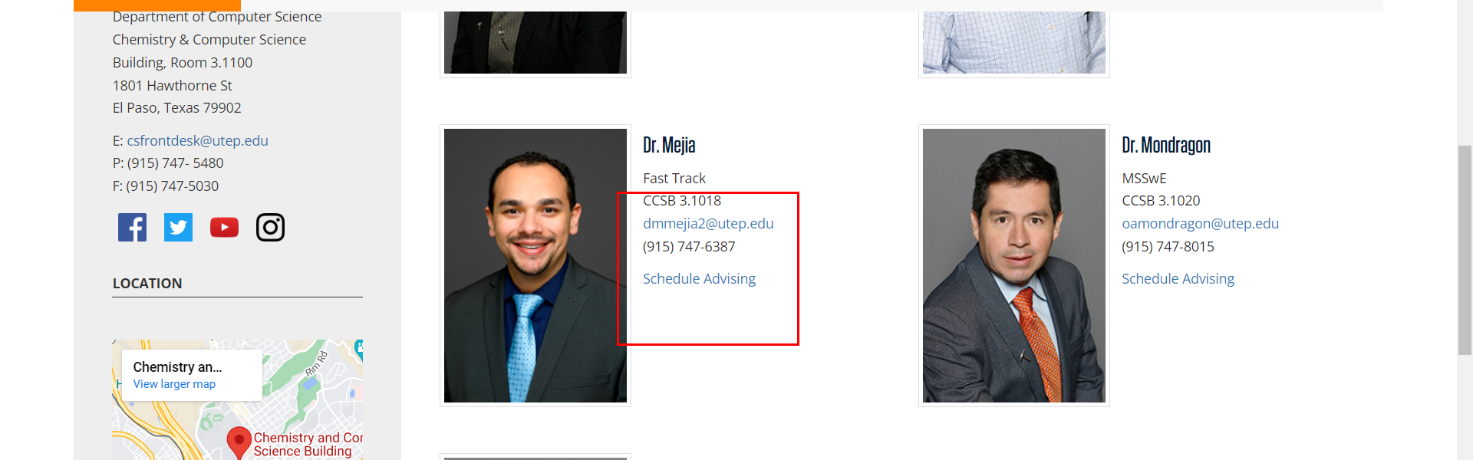

• Broken link on <https://www.utep.edu/cs/advising/Advising_page/graduate-advising.html> on **Main Content** section, the broken link is displayed as: **Schedule Advising** and the link is pointing to : [https://outlook.office365.com/owa/calendar/ComputerScienceAdvising1@minersutep.onmicrosoft.com/bookings/s/MMitx8tTB0K7GXt3HyJH5A2](https://outlook.office365.com/book/ComputerScienceAdvising1@minersutep.onmicrosoft.com/s/MMitx8tTB0K7GXt3HyJH5A2?isAnonymous=true)

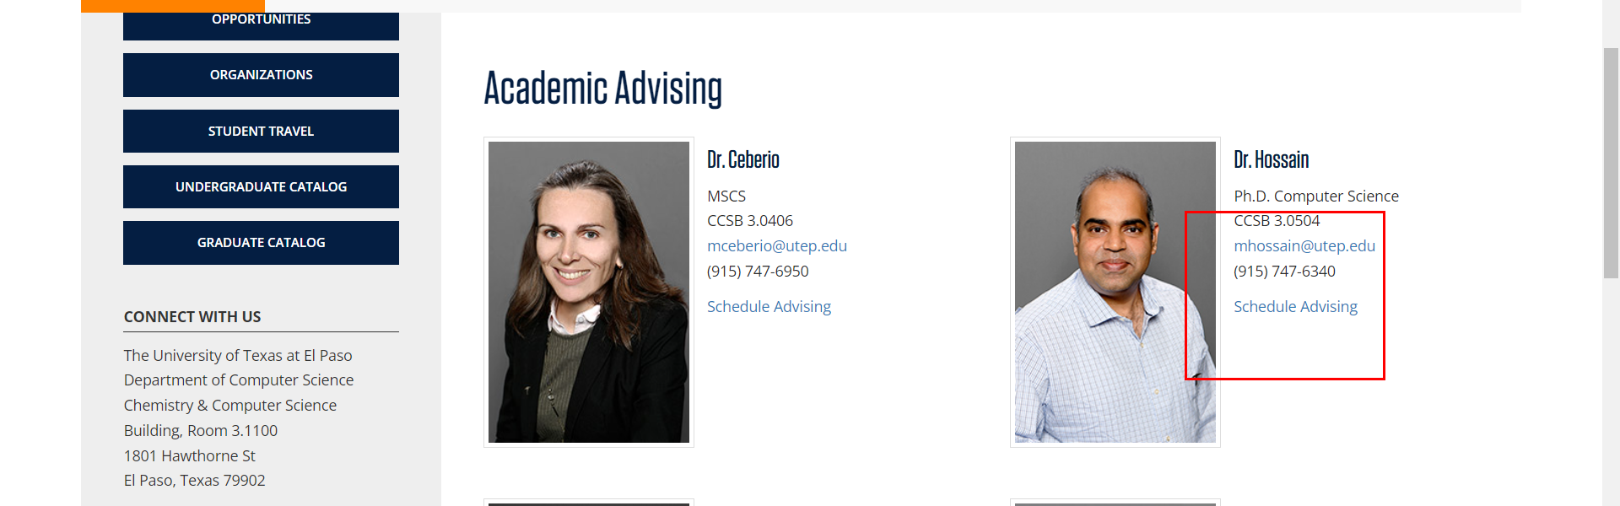

• Broken link on <https://www.utep.edu/cs/advising/Advising_page/graduate-advising.html> on **Main Content** section, the broken link is displayed as: **Schedule Advising** and the link is pointing to : [https://outlook.office365.com/owa/calendar/ComputerScienceAdvising1@minersutep.onmicrosoft.com/bookings/s/JWiEk-jt7EKSZxrVB5uhUA2](https://outlook.office365.com/book/ComputerScienceAdvising1@minersutep.onmicrosoft.com/s/JWiEk-jt7EKSZxrVB5uhUA2?isAnonymous=true)

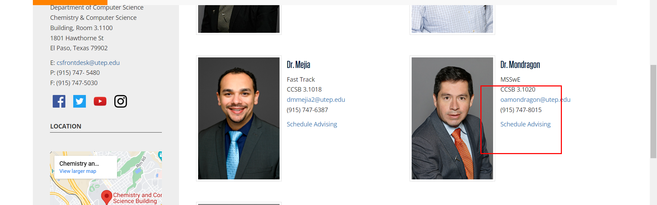

• Broken link on <https://www.utep.edu/cs/advising/Advising_page/graduate-advising.html> on **Main Content** section, the broken link is displayed as: **Schedule Advising** and the link is pointing to : [https://outlook.office365.com/owa/calendar/ComputerScienceAdvising1@minersutep.onmicrosoft.com/bookings/s/chAVE89JQEyXjpf8NSdxyA2](https://outlook.office365.com/book/ComputerScienceAdvising1@minersutep.onmicrosoft.com/s/chAVE89JQEyXjpf8NSdxyA2?isAnonymous=true)

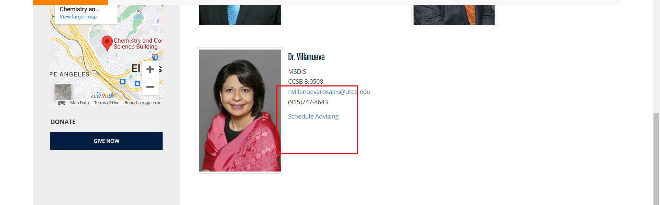

• Broken link on <https://www.utep.edu/cs/advising/Advising_page/index.html> on **Main Content (Top small navigation)** section, the broken link is displayed as: **advising** and the link is pointing to : <https://www.utep.edu/cs/advising/>

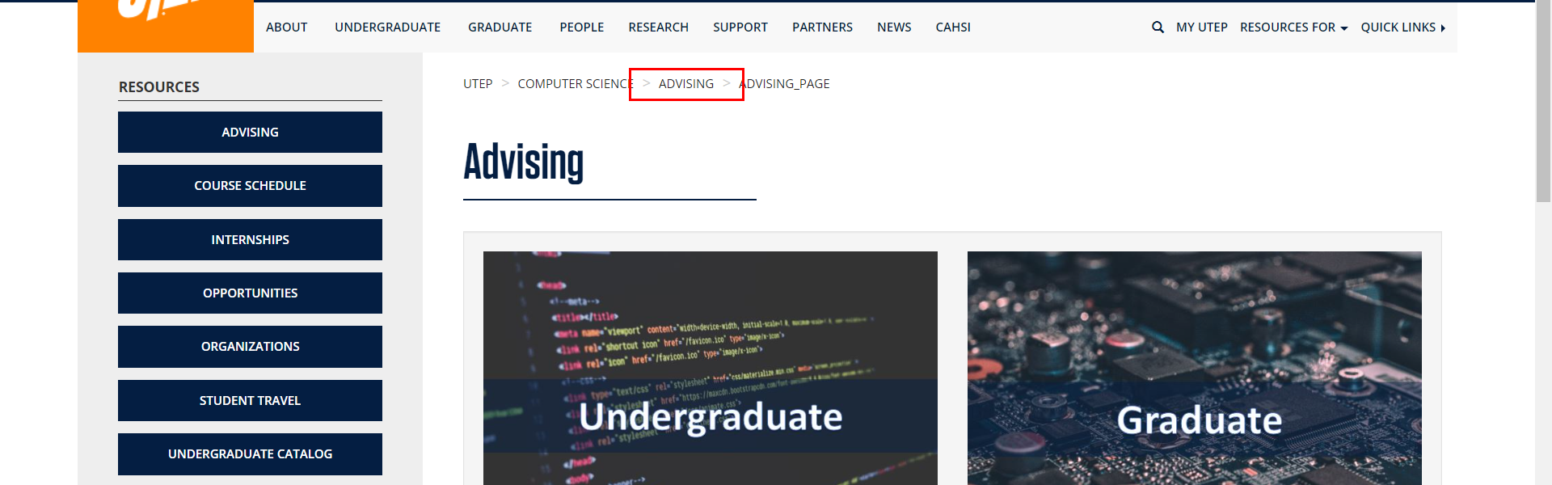

• Broken link on <https://www.utep.edu/cs/advising/Advising_page/undergraduate-advising.html> on **Main Content (Top small navigation)** section, the broken link is displayed as: **advising** and the link is pointing to : <https://www.utep.edu/cs/advising/>

